2016 Santa Anita Derby Contenders

1 Denman’s Call (3: 1-1-1) 15-1 HSF: 101
Jockey: Rafael Bejarano (different from last start)
Race Record: Just three starts, none of them longer than 7f. Only win was his 5.5f maiden (pp. 10/11) at Santa Anita (all starts were at SAP) in January. Most recent start was the 6f San Pedro Stakes, which he came 2nd in. Came third in the 7f race- seems to clearly indicate that increasing distance is an issue for him.
Pedigree: Northern Afleet x Maggie McGowan, by Salt Lake. Northern Afleet is a son of Afleet, by Mr. Prospector, and out of Nureyette, a Nureyev daughter (Nureyev was by Northern Dancer and Special). Salt Lake is a Deputy Minister son. Maggie McGowan actually has some good blood through her dam, Jewel of the Night, a daughter of Giants Causeway (by Storm Cat) and a mare whose direct sire line leads to Seattle Slew, thus present in Denman’s Call’s 5th generation.
Conformation:
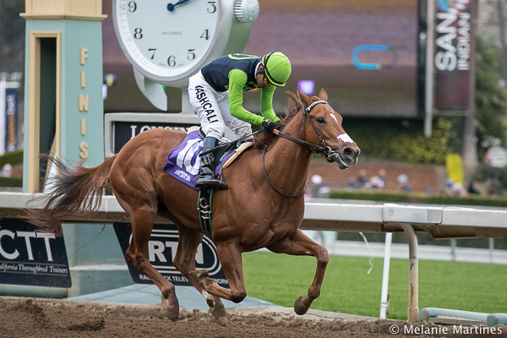

2 Exaggerator (8: 3-2-1) 4-1 HSF: 105
Jockey: Kent Desormeaux (same as last start)
Race Record: Won Delta Downs (8.5f), but came second and third in the San Vicente (6.5f) and San Felipe (8.5f) races, respectively, at Santa Anita. San Felipe in particular had several other contenders from today’s field. Notes from Delta Downs indicate that he barely lasted for the mile and a sixteenth, although that race was in November, so it’s possible that he could have built up some more endurance. **Delta Downs track was muddy but sealed when he ran, also came second in a 8.5f Keeneland race when the track was muddy**
Pedigree: Seattle Slew on dam’s side
Conformation:
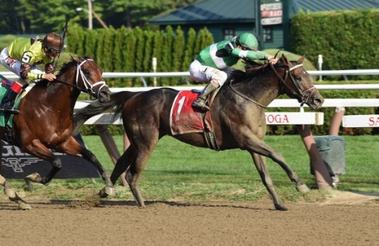

3 Danzing Candy (4: 3-0-0) 9-5 HSF: 110
Jockey: Mike Smith (same as last start)
Race Record: Won the San Felipe, as well as his maiden and then an allowance race at SAP. Seems to be a frontrunner and certainly has the speed to handle that. Not super convinced that Mor Spirit won’t end up outlasting him here today, however, and I’m guessing that other handicappers feel the same way based on the fact that Mor Spirit’s odds are just a little bit tighter.
Pedigree: Candy Ride as sire’s sire; Danzig in sire’s dam’s line. Dam’s sire line goes back to Unbridled.
Conformation:
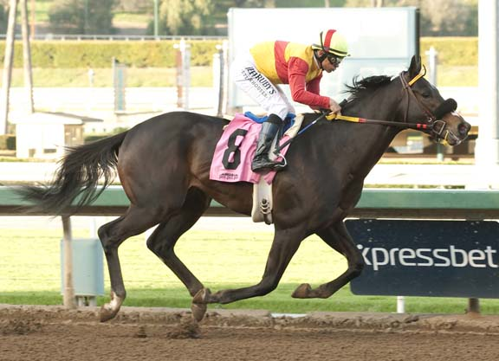

4 Mor Spirit (6: 3-3-0) 8-5 HSF: 108
Jockey: Gary Stevens (same as last start)
Race Record: Carried the most weight in the San Felipe (pp. 3/6), which is the same as all the horses are carrying today (124lbs). Seems to do best stalking just off the pace, which he didn’t quite do in the San Felipe (but did do in the Lewis Stakes, also at SAP), likely the reason why he couldn’t ultimately catch up with Danzing Candy. That said, he was only 2 lengths away. If he stays closer to the pace today and is held back until the stretch, I think he could make a successful bid for first, and possibly finish in the money even if he’s ultimately outraced by someone else in the field.
Pedigree: LOTS of Northern Dancer, but all 4th or 5th generation, and there doesn’t seem to have been much of a negative effect on his conformation from it. Seattle Slew on both sides, including 3rd generation sire line.
Conformation: Solid build (based on racing action shot)

5 Smokey Image (7: 6-0-0) 15-1 HSF: 108 (98 this year)
Jockey: Victor Espinoza (same as last start)
Race Record: Of all the horses who are San Felipe alums today, Smokey Image finished the worst, coming 6 out of 6 (and coming from post position 6/6 as well). Yet in January, he raced at SAP in the California Cup Derby, also 8.5f, and won by an astounding 8.5 lengths, carrying 123lbs (the most of any horses on the field that day). Granted, the horses he was up against might not be the caliber of today, but I think the reason he went from being undefeated over several race tracks and distances comes from the post position and his running style. In the San Felipe, he was in the furthest outside post position. Being the frontrunner is clearly what worked for him in the Cal Cup Derby (pp. 2/7), but Danzing Candy took that from him in the San Felipe and he couldn’t get close enough to the rail to do his thing. Today, Danzing Candy will definitely have the rail advantage, but Smokey Image will also be in the middle of the pack. If he can break well, he can try and press Danzing Candy along the rail. Maybe he can last through that, but ultimately he may serve the pawn goal of tiring Danzing Candy out. Based on his previous win streak and the fact that he romped in the Cal Cup Derby, I’ll definitely place a show bet on him.
Pedigree: Direct sire line to Halo in 3rd generation. Dam’s damsire is Smart Strike. Sire’s damsire is Dixieland Band. 2x Northern Dancer, one on either side- 4th generation on sire’s side and 5th generation on dam’s side.
Conformation: Heavily muscled, determined. Slight nervous neck bulge.

6 Iron Rob (10: 3-2-0) 12-1 HSF: 105
Jockey: George Papaprodromou (different from last start)
Race Record: Lots of starts only because it took him 7 tries to break his maiden. When he did break it, it was just 5.5f. Last two wins were at SAP, but the longest of the two as 6.5f. Really not sure why his odds are so low?
Pedigree: Pretty nice pedigree for long distance. Sire is the same as Danzing Candy (Twirling Candy). Dam’s side is where it’s at, which is good: sire Tiger Ridge combines Storm Cat with Weekend Surprise (AP Indy and Summer Squall’s dam), and dam Lady Cruella is by Capote (son of Seattle Slew) and a Mr. Prospector daughter. 2x Secretariat, 2x Seattle Slew, 2x Mr. Prospector, and 2x Northern Dancer. All inbreeding relegated to the 4th and 5th generations.
Conformation: Seems like his hind end might be slightly smaller than his shoulder. Great leg to barrel ratio. Legs in general look clean. Good slopey shoulder.

7 Dressed in Hermes (7: 3-0-1) 15-1 HSF: 107 (100 this year)
Jockey: Flavien Prat (different from last start)
Race Record: Last start was in a one mile turf race at SAP (pp. 1/6), which he won by ¾ of a length. Despite being my original favorite for the Sham Stakes (before he scratched), I have serious doubts as to his ability to handle such an increase in distance.
Pedigree: Hat Trick x Elusive Fashion, by Elusive Quality. Hat Trick is a wildly successful Japanese sprinter/miler, and a son of Sunday Silence, who won the Kentucky Derby, Preakness, and came 2nd in the Belmont, then won the Breeder’s Cup Classic. Elusive Quality, DiH’s damsire, is a son of Gone West, the progeny of Mr. Prospector and Secretariat daughter Secrettame. I like this pedigree. There isn’t really any inbreeding in the first 5 generations, and I like that Secretariat is on the dam’s side with Sunday Silence on his sire’s side.
Conformation:
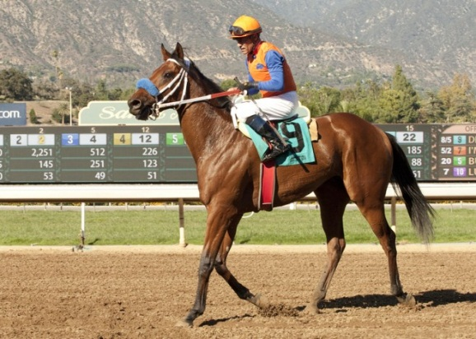

8 Rare Candy (8: 1-3-0) 30-1 HSF: 102
Jockey: Joe Talamo (same as last start)
Race Record: Came 7th in the Sham Stakes, and most recently came 2nd in an 8f allowance optional claiming race at SAP (pp. 3/5) a couple weeks ago- March 27th. A little over a month before that he came 2nd in another allowance optional claimer at SAP (pp. 7/7) that was one mile on the turf.
Pedigree: Twirling Candy x Bold Pegasus, by Fusaichi Pegasus. Twirling Candy is a son of Candy Ride, a successful, undefeated Argentinian miler who can trace his lineage back to Mr. Prospector through Fappiano; in Rare Candy’s pedigree, Fappiano is in the 5th generation. Fusaichi Pegasus is also a son of Mr. Prospector, with ties to Danzig through his dam. However, that’s only one of two Mr. Prospector/Danzig damsire pairings in Rare Candy’s pedigree- Twirling Candy’s dam (House of Danzing) is a granddaughter of Mr. Prospector through her sire, and a granddaughter of Danzig through her dam. Overall, this pedigree is really heavy on Mr. Prospector for my complete liking, but the added Danzig is interesting. Additionally, Seattle Slew is present through Twirling Candy’s damsire in Rare Candy’s 5th generation.
Conformation: Kind of narrow in front but good hindquarters it looks like:
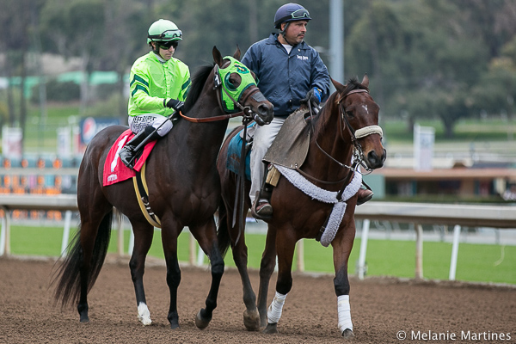

9 Diplodocus (5: 1-0-0) 30-1 HSF: 99
Jockey: Tyler Baze (different from last start? Russell Baze in El Camino- related?)
Race Record: I had some high hopes for Diplodocus in the El Camino Real Derby, but he ultimately only came in 5th place. What went wrong? He was racing too far toward the back of the pack for his closing drive to be successful, plus never really put on a lot of speed. That said, he was only 4 lengths behind the winner, and this was 5th in a field of 13, so not altogether too bad. Plus, he broke his maiden at Santa Anita, which tells me he’s at least familiar with the turf track there. Maybe I should have learned my lesson, but I’m going to place another show bet.
Pedigree: Sky Mesa x Speciality, by Carson City. Sky Mesa is by Pulpit, an AP Indy son, and out of Caress, a daughter of Storm Cat. Additionally, Caress’s dam is an Affirmed daughter. Speciality’s pedigree is similarly star-studded: sire Carson City is a Mr. Prospector son and dam Special feeling has a direct sire line to Danzig. Mr. P is twice on either side, with Raise a Native 3x (twice on dam’s), Northern Dancer on either side, and Secretariat 2x on sire’s side.
Conformation: No pics.

10 Uncle Lino (5: 1-2-1) 20-1 HSF: 106
Jockey: Fernando Perez (same as last start)
Race Record: Finished 8 ¾ lengths ahead of Smokey Image, but a total of 10 lengths behind Danzing Candy in the San Felipe (pp. 1/6). Was up by the pace initially but then weakened. Highly doubt he can handle today’s race if he began weakening after ½ mile in an 8.5f race. His one win was breaking his maiden at Del Mar in late November, at 6.5f (pp. 2/12), running at the front for most of the race.
Pedigree: Uncle Mo sire. Dam has a direct sire line to Blushing Groom and dam’s sire is Unbridled, by Fappiano.
Conformation:
